You will go to:
https://courses.labster.com/activate/dcb32fb216d9492ca4a10b37c39d0c68
click on log in at the top right
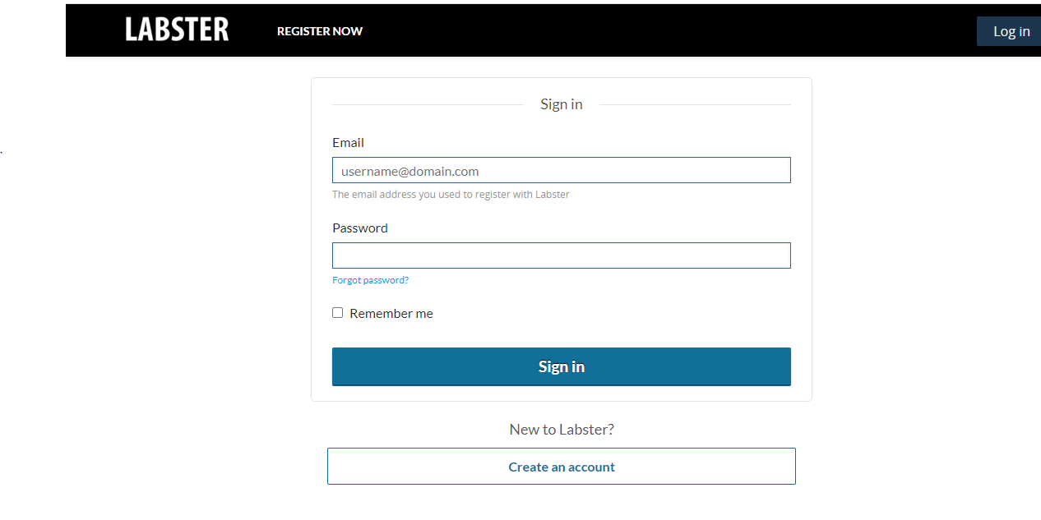
Once you see this
Email to put in is nt713851@gmail.com
Password is William28

You will see Org Chem 1 Summer Session 2 click on view course
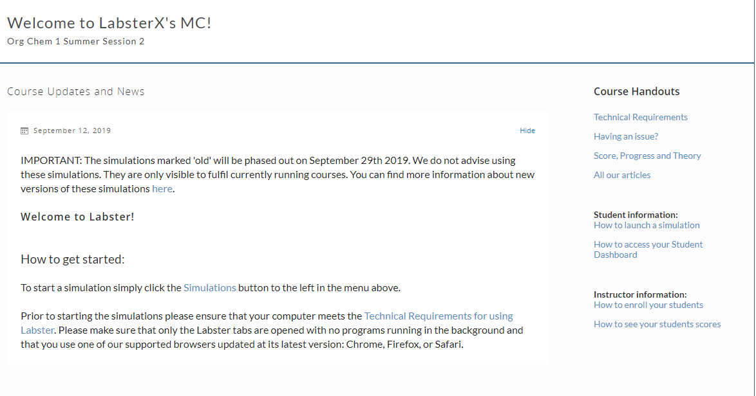
You will click on Simulations you will see this
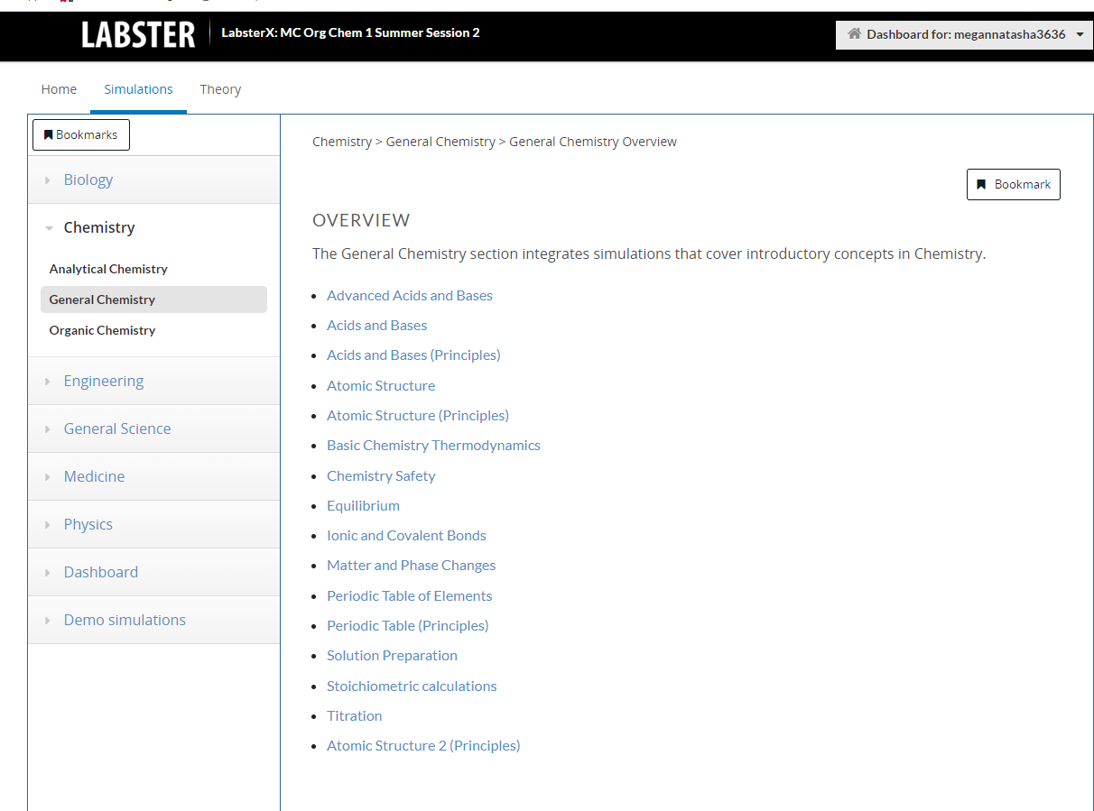
Click on General Chemistry and complete Advanced Acid and Base (General Chemistry)
Once complete you will go back to simulations click on organic chemistry and complete
Elimination reaction (Organic Chemistry)

Elimination and Substitution Reaction (Organic Chemistry)

Reactivity rule (Organic Chemistry)

Nucleophilic addition: Explore the Grignard reagent (Organic Chemistry)

Once 5 labs complete please email me with completion and report in word format
They are 10 minute labs

Thank you

Only 5 items to complete
Advanced Acid and Base (General Chemistry)
Elimination reaction (Organic Chemistry)

Elimination and Substitution Reaction (Organic Chemistry)

Reactivity rule (Organic Chemistry)

Nucleophilic addition: Explore the Grignard reagent (Organic Chemistry)

